**How to check whether you qualify for a contextual offer based on your Post Code**

Step-by-step guide to check the IMD Quintile of your home postcode

1. Use the English indices of deprivation 2019 data [lookup tool](https://imd-by-postcode.opendatacommunities.org/imd/2019).
2. Type your home postcode in the ‘Enter postcodes’ box.
3. Click ‘Get deprivation data'.
4. The data for your home postcode will be available as an xlsx or csv file. To open in Excel, download the xlsx file.

[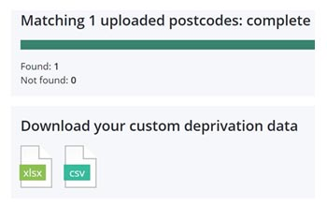](https://imd-by-postcode.opendatacommunities.org/imd/2019)

Column F in the downloaded spreadsheet gives you the Index of Multiple Deprivation Decile. This will be a number from 1 to 10.

In the example below the IMD Decile is 9, for postcode NR2 2LJ,

1. Determine the IMD Quintile:
   * Decile 1 or 2 = IMD Quintile 1
   * Decile 3 or 4 = IMD Quintile 2
   * Decile 5 or 6 = IMD Quintile 3
   * Decile 7 or 8 = IMD Quintile 4
   * Decile 9 or 10 = IMD Quintile 5
2. Make a note of the IMD Quintile of your home postcode.

If your home postcode is IMD Quintile 1 or 2, you will qualify for a contextual offer.